MOLES

A mole is used to measure, compare and calculate in Chemistry. It is defined as follows.

Mole: the number of atoms in 12.00 g of carbon-12.

The number of atoms in 1.00 mole of an element is given by Avogadro's Number.

Avogadro's Number: equal to 6.02 x 10²³ particles/atoms/molecules/etc.

∴ 1.00 mole of Al atoms = 6.02 x 10²³ atoms

1.00 mole of O₂ molecules = 6.02 x 10²³ molecules

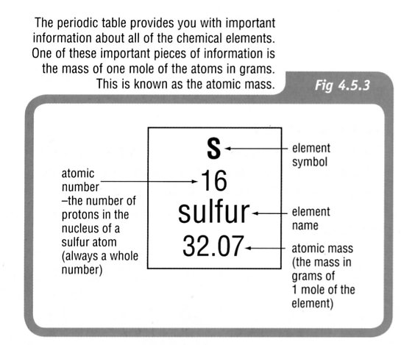
Molar Mass

A periodic table shows two important numbers when dealing with atoms. The atomic number is generally shown in the top left of the symbol box while the atomic mass of the element is shown elsewhere in the box.

All atomic masses of the Periodic Table are compared to C-12.

Atomic Mass: the mass of an atom compared to of the mass of a carbon-12 atom.

Molecular/Formula Mass: the mass of a molecule (covalent substance) or formula unit (ionic
substance) compared with of the mass of a carbon-12 atom.

Molar Mass: 1.00 mole of any substance is its atomic, molecular, or formula mass expressed
in grams.

e.g. The molar mass is calculated by adding together the individual atomic
masses.

M(CuSO₄) = M(Cu) + M(S) + 4 x M(O)
= 63.5 + 32.1 + 4(16.0)
= 159.6 gmol⁻¹.
The relationship between moles and mass is given by:

where n = number of moles of a substance (mol)
m = mass of substance (g)
M = molar mass of the substance (gmol⁻¹)

Examples

1. What is the mass of 4.29 moles of AlPO₄?

2.
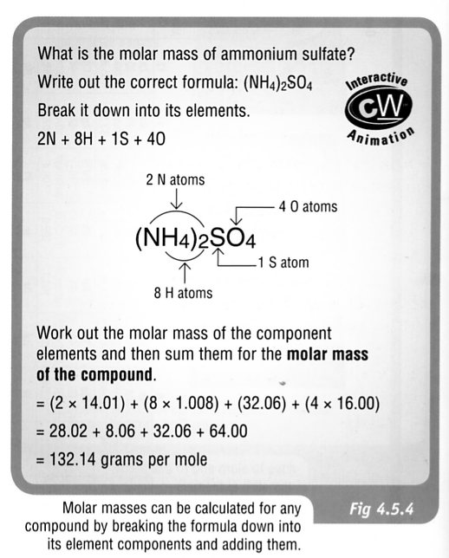
3.
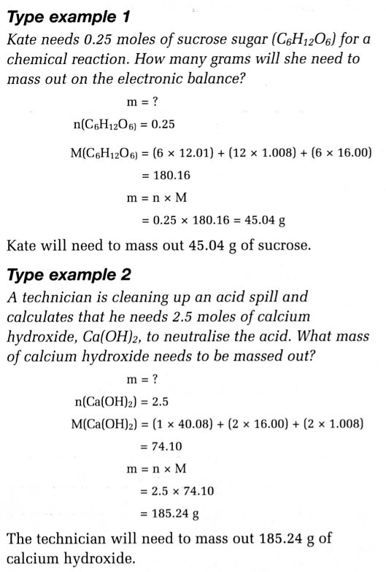

CHEMICAL CALCULATIONS AND EQUATIONS (STOICHIOMETRY)

A balanced chemical equation gives information about how the atoms rearrange during the chemical change process. It also gives information about the ratios between the number of particles of reactants and products.

This allows calculations to be made and a prediction about the amounts of substances needed or produced during a chemical reaction. This is very important for controlling reactions and minimising costs in business and industry.

The key to chemical calculations is found at the mole level. It gives you the molar ratio of reactants to products, which is the key to solving problems in chemistry.

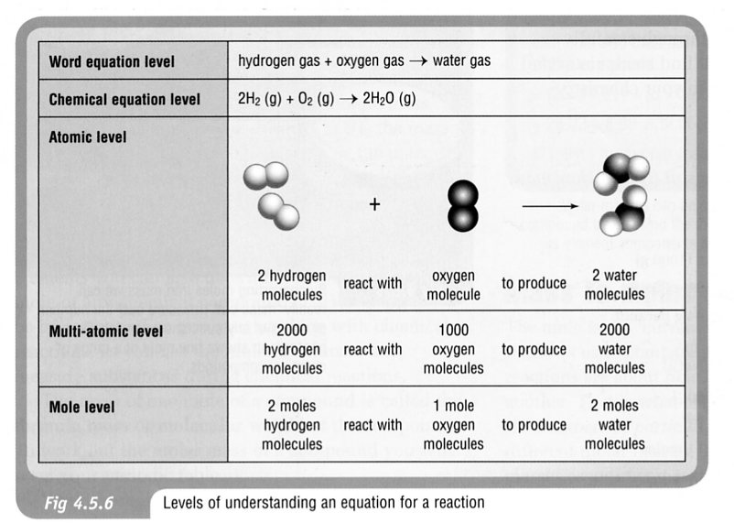

Example

73.2 grams of Al₂(CO₃)₃ is reacted with excess HCl acid. Calculate:

(a) the mass of HCl used.
(b) the mass of CO₂ produced.

Step 1 Write a balanced equation.

Al₂(CO₃)_{3 (s)} + 6 HCl _{(aq)} ----> 2 AlCl₃ _{(aq)} + 3 CO₂ _{(g)} + 3 H₂O _{(l)}

Step 2 Put a tick under the substances you “know” the mass of, and a question mark
under the substances you need to find.

Al₂(CO₃)_{3 (s)} + 6 HCl _{(aq)} ----> 2 AlCl₃ _{(aq)} + 3 CO₂ _{(g)} + 3 H₂O _{(l)}
✓   ? ?
Step 3 Convert the “known” mass to number of moles.

Step 4 Use the balanced equation (mole ratios) to work out the number of moles of the
“unknown” substance.

Step 5 Convert the “unknown” number of moles to mass.

(a)

(b) In this calculation, repeat steps 4 and 5.

